#### **Pumpkin Pie**

Courtesy of Sally’s Baking Addiction

*In the spirit ofThanksgiving, I wanted to go as traditional as possible. So here is the world’s best pumpkin pie recipe. It’s rich, moist, sweet, and earthy and tastes absolutely spectacular!*

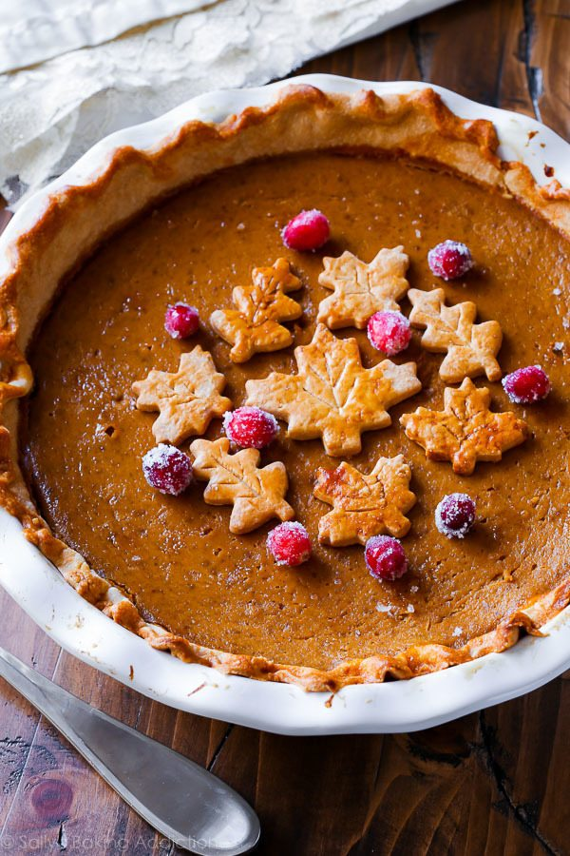

**Ingredients**

**For Pie Crust:**

* + 2 and 1/2 cups (313g) all-purpose flour ([spoon & leveled](https://sallysbakingaddiction.com/how-to-measure-baking-ingredients/))
  + 1 teaspoon salt
  + 6 Tablespoons (90g) unsalted butter, chilled and cubed
  + 3/4 cup (148g) vegetable shortening, chilled
  + 1/2 cup (120ml) ice water

**For Filling:**

* + one 15oz can (about 2 cups; 450g) pumpkin puree*
  + 3 large eggs
  + 1 and 1/4 cups (250g) packed light or dark brown sugar
  + 1 Tablespoon (8g) cornstarch
  + 1/2 teaspoon salt
  + 1 and 1/2 teaspoons ground cinnamon
  + 1/2 teaspoon ground ginger*
  + 1/4 teaspoon ground or freshly grated nutmeg*
  + 1/8 teaspoon ground cloves*
  + 1/8 teaspoon fresh ground black pepper
  + 1 cup (240ml) heavy cream
  + 1/4 cup (60ml) milk (I use 1% – any is fine)
  + egg wash: 1 large egg beaten with 1 Tablespoon milk

### **Instructions**

**Make the pie crust:**

1. Mix the flour and salt together in a large bowl. Add the butter and shortening.
2. Using a pastry cutter ([the one I own](http://www.amazon.com/OXO-Grips-Dough-Blender-Blades/dp/B000QJE48O?tag=sallsbakiaddi-20)) or two forks, cut the butter and shortening into the mixture until it resembles coarse meal (pea-sized bits with a few larger bits of fat is OK). A pastry cutter makes this step very easy and quick.
3. Measure 1/2 cup (120ml) of water in a cup. Add ice. Stir it around. From that, measure 1/2 cup (120ml) water since the ice has melted a bit. Drizzle the cold water in, 1 Tablespoon (15ml) at a time, and stir with a rubber spatula or wooden spoon after every Tablespoon (15ml) added. Stop adding water when the dough begins to form large clumps. I always use about 1/2 cup (120ml) of water and a little more in dry winter months (up to 3/4 cup). Do not add any more water than you need.
4. Transfer the pie dough to a floured work surface. The dough should come together easily and should not feel overly sticky. Using floured hands, fold the dough into itself until the flour is fully incorporated into the fats. Form it into a ball. Cut dough in half. Flatten each half into 1-inch thick discs using your hands.
5. Wrap each tightly in plastic wrap. Refrigerate for at least 2 hours and up to 5 days.
6. When rolling out the chilled pie dough discs to use in your pie, always use gentle force with your rolling pin. Start from the center of the disc and work your way out in all directions, turning the dough with your hands as you go. Visible specks of butter and fat in the dough are perfectly normal and expected!

**For the pumpkin pie filling:**

1. Whisk the pumpkin, 3 eggs, and brown sugar together until combined. Add the cornstarch, salt, cinnamon, ginger, nutmeg, cloves, pepper, cream, and milk. Vigorously whisk until everything is combined.
2. Preheat oven to 375°F (190°C).
3. Roll out the chilled pie crust: Remove 1 disc of pie dough from the refrigerator. On a lightly floured work surface, roll the dough out into a 12-inch circle. Make sure to turn the dough about a quarter turn after every few rolls. Carefully place the dough into a 9-inch deep dish pie dish. Tuck it in with your fingers, making sure it is smooth. With a small and sharp knife, trim the extra overhang of crust and discard. Crimp the edges with a fork or flute the edges with your fingers, if desired. Brush edges lightly with egg wash mixture. Line the pie crust with parchment paper. Crunching up the parchment paper is helpful so that you can easily shape it into the crust. Fill with [pie weights](https://www.amazon.com/Mrs-Andersons-Baking-Ceramic-Weights/dp/B00004S1BT?ie=UTF8&creativeASIN=B0113L930C&linkCode=xm2&redirect=true&tag=sallsbakiaddi-20) or dried beans. (Note that you will need at least 2 standard sets of pie weights to fit.) Make sure the weights/beans are evenly distributed around the pie dish. Par-bake the crust for 10 minutes. Carefully remove the parchment paper/pie weights.
4. Pour pumpkin pie filling into the warm pre-baked crust. Only fill the crust about 3/4 of the way up. *(If using a deep dish pie dish as instructed, you should only have a little filling leftover. Use extra to make mini pies with leftover pie dough scraps if you’d like.)* Bake the pie until the center is almost set, about 55-60 minutes give or take. A small part of the center will be wobbly – that’s ok. After 25 minutes of baking, be sure to cover the edges of the crust with aluminum foil or use a pie crust shield to prevent the edges from getting too brown. Check for doneness at minute 50, and then 55, and then 60, etc.
5. Once done, transfer the pie to a wire rack and allow to cool completely for at least 3 hours.

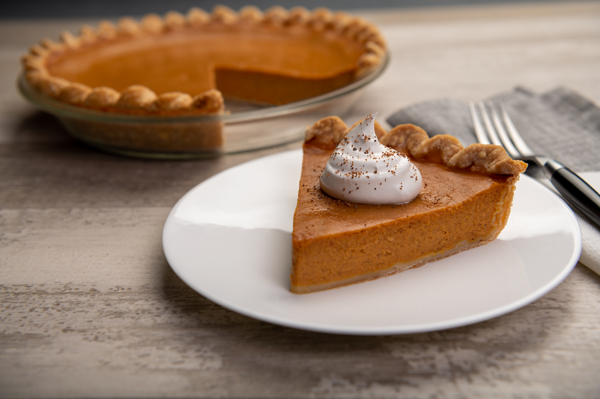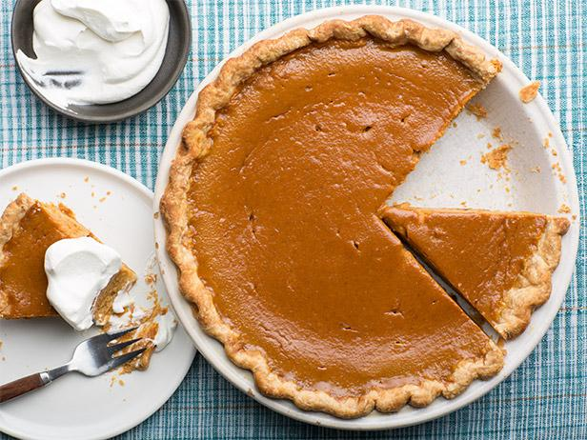

**Vegan Stuffing**

Courtesy of Love and Lemons

*I think it’s important that everyone can be included in a Thanksgiving Feast, so, here’s a classical recipe, with a twist. This vegan stuffing is so tasty, you won’t even miss the meat, and, the best part is, it doesn’t only have to be part of the Thanksgiving table, it can honestly be eaten every day.*

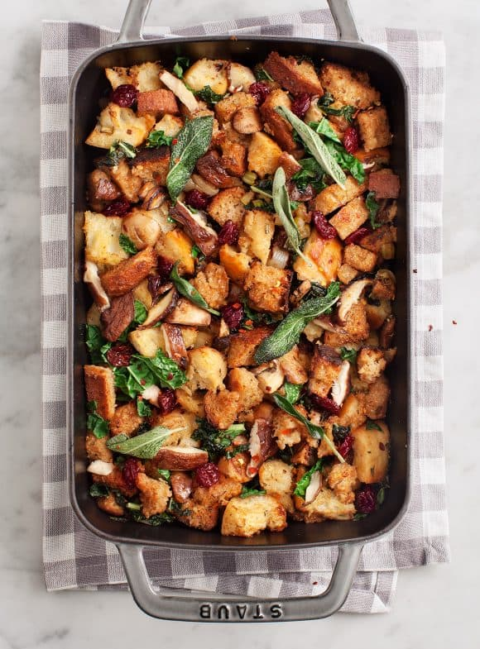

### **Ingredients**

* 6 tablespoons [extra-virgin olive oil](https://amzn.to/2Mm3S0m), divided
* 1 cup coarsely chopped cipollini onions
* 3 cups chopped & stemmed mushrooms, mix of shiitake & cremini
* 3 garlic cloves, minced
* 2 stalks celery, diced
* 1/4 cup chopped sage, plus 8 leaves for garnish
* 2 tablespoons minced rosemary
* 2 tablespoons balsamic vinegar
* 5 cups cubed crusty ciabatta + nine-grain bread*
* 3 kale leaves, coarsely chopped or torn
* 2 cups [vegetable broth](https://amzn.to/3j8GWhd), plus more for reheating
* 1/4 cup dried cranberries
* Sea salt and freshly ground black pepper

### **Instructions**

1. Preheat the oven to 350°F and grease an 8x12 or 9x13 casserole dish.
2. In a very large skillet, heat 2 tablespoons of olive oil over medium heat. Add the onions, mushrooms, 1/2 teaspoon salt, and several grinds of fresh pepper, and let the mushrooms cook until they begin to soften, 5 to 8 minutes, stirring only occasionally. Add the garlic, celery, sage, and rosemary, and cook until everything is soft and the mushrooms are golden brown, 8-10 minutes.
3. Add the balsamic vinegar, stir, and scrape any bits off the bottom of the pan. Add the bread and the remaining 1/4 cup olive oil and toss to coat. Add the kale and cook until it begins to wilt about 1 minute. Add 1 cup of the broth and stir.
4. Transfer to a casserole dish and pour the remaining 1 cup broth evenly over the stuffing.
5. Sprinkle with the dried cranberries, remaining whole sage leaves and bake for 20 minutes or until golden brown. Let sit for at least 15 minutes or until ready to serve.